End-User Requirements – EUR-I2302029Rev2
  - DBOX ENHANCEMENT
Quick configurator parant and child layout change

Irpinia Kitchens

Document Approval
Approver | Approved Date | Rejected Date | Comments

Part 1: Functionality Overview
- Objectives (Why are we doing this?)
As per Irpinia’s business model, DBOX quick config to be maximum effective when quote is creating by Irpinia’s users or dealers.
- Change the parent/child configurator layout to show the parent configurator properties in a similar fashion to the image presented below
  - Parent options:
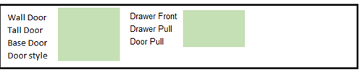

  - Child options:
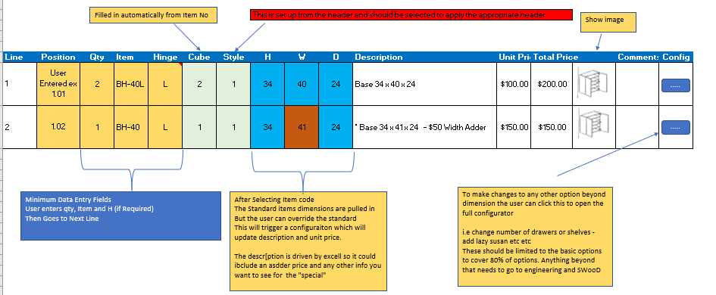

- The user will be able to select the mastered item from the list, example BH-40L. This will automatically field the columns: Item, Hinge, Cube, Stype, H, W, D, and image (file path) will be configurator properties
- The column “ Position” should be empty and editable. The user will add the cabinate position in this field manually. – This will be a configurator property
- The field Hinge to be defaulted to Left and if necessary to be changed manually.
- The fields H, W and D to be editable in case that the user would like to change some of the parametars.
- There should be a button that will allow the user to open the child config properties in order to changes something that is not in the main grid.
- Other productlines can be created and associated to the Parent Productline to deal with a variety of user scenarios – such as custom, non defined products
- Enhance DBox to allow selecting any Configurator Property to display regardless of where it is in the property list.
- Enhance DBox to allow setting the column order for the Child Configurators.

- User Roles and Responsibilities
  - Seradex to change the DBOX interface as proposed.
  - Irpinia to create new configurator file to match the proposed DBOX interface configuration.
- Interactions with Other Systems
  - N/A
- Production Rollout Considerations
- Terminology

Part 2: Functional Requirements

Part 4: Change Order Details

Date | Enhancement | Requested By | Notes | Priority | Release Status

Please note that custom reports or searches are not included in the scope of this EUR.

